**Instructions for Visiting Bat Country**

Overview

G’day Mate!

This journey will take you, the walker, from the lobby of UNSW Village to “Bat Country”. Bat Country is a casual, rustic cocktail bar inspired by the film Fear and Loathing in Las Vegas, a 1998 comedy adventure film directed by Terry Gilliam. Along the way, there will be a brief stop to explore the UNSW Fig Tree Courtyard. This stop will provide a nice break from the walk and give a glimpse of a possible study place for a student at UNSW.

A trip overview is shown in Figure 1.

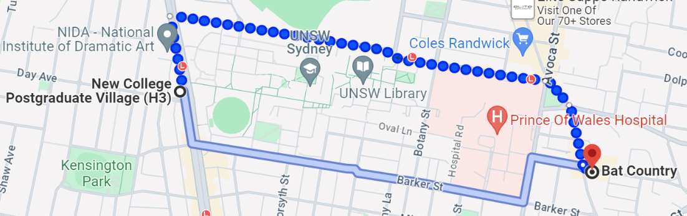



*Figure 1: Overview of the walking route*

Note: There are five main steps throughout this journey.

Step 1: Yellow Highlight

Step 2: Green Highlight

Step 3: Blue Highlight

Step 4: Red Highlight

Step 5: Orange Highlight

**INSTRUCTIONS**

**Step 1: From UNSW Post Graduate Village to High Street**

1. Go out the back gates by the common room and start walking straight towards High Street on Anzac Parade.
2. Turn left out of the New College Postgraduate Village so that you are facing North on Anzac Parade Street.
3. Walk North on Anzac Parade Street. for 300 m (about 980 ft) to High Street. *This will take approximately 4 minutes.*
4. Turn right onto High Street, so that you are on the right side of the road.

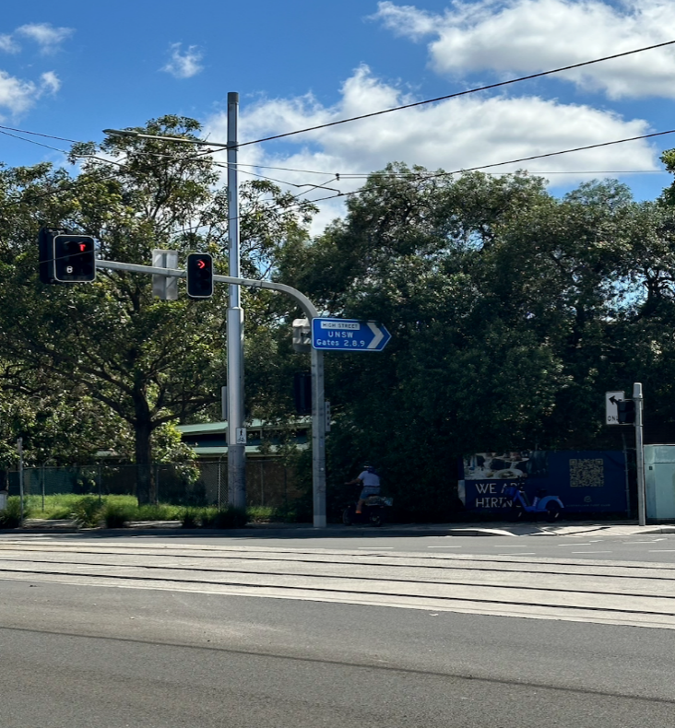

*Figure 2: View on Anzac and turn right onto High Street*

**Step 2: From High Street to Fig Tree Courtyard at UNSW**

1. Continue walking East along the right side of High Street for 350 m. This *will take approximately 5 minutes.*
2. Once you see the UNSW Gate 5 sign, turn right onto Gate Five Avenue, a small side street on your right. The view of your turn location is shown below in Figure 3.

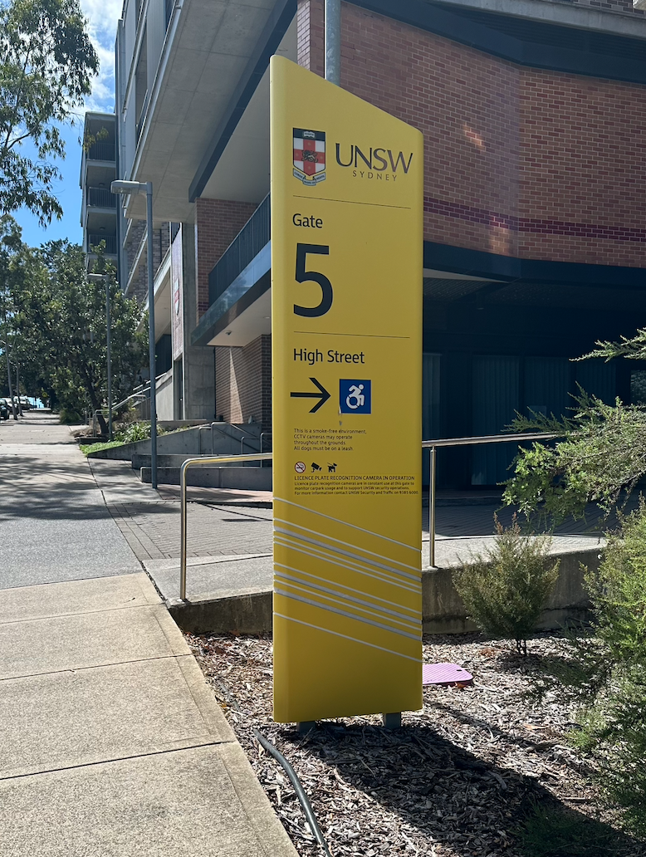

*Figure 3: A view of Gate Five Ave. off High Street*

1. Continue straight for ~90 m (~1-2-minute walk) until you encounter a series of 2 white pots in the middle of the road depicted in Figure 4.
2. Take the next left onto a small staircase shown below in Figure 4 shortly past the white pots.

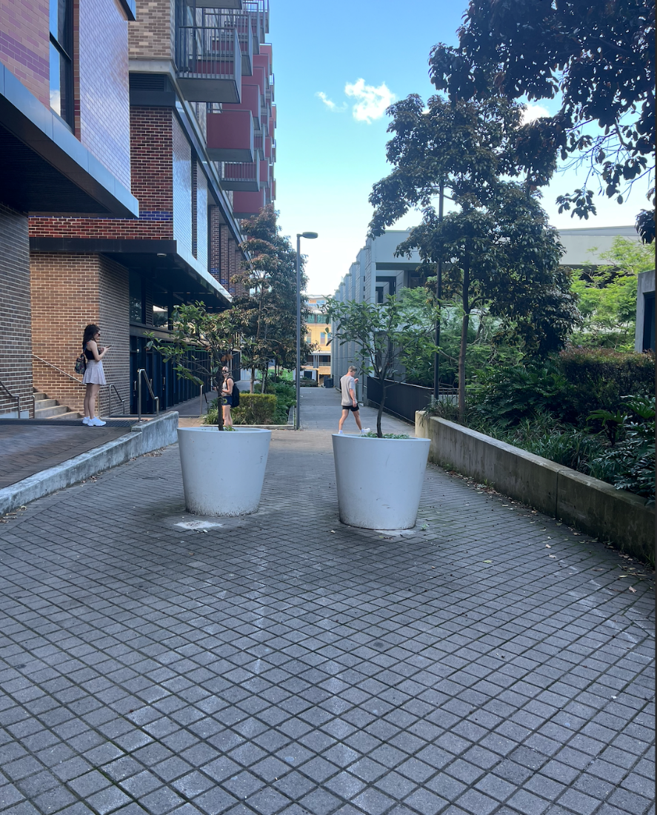

*Figure 4: A view of the large white pots*

1. Continue up the steps and enjoy the view of the Fig Tree courtyard.
2. Continue straight across the grass to the staircase going upward.
3. Once at the top of the staircase, turn left.
4. Walk straight until you come upon UNSW Gate 7 Sign.
5. Take a right back onto High Street.

**Step 3: From Fig Tree Courtyard at USNW to Belmore Road**

1. Proceed East on High Street for 1.6 km. *This will take approximately 20 minutes.*
2. After passing a rail station, you will reach an intersection which includes Belmore Road and Avoca Street. This intersection is a little wonky, but you will walk straight, with a slight right.

**Step 4: From Belmore Road to Perouse Road**

1. Use the crosswalk to cross Avoca Street.
2. Continue down Belmore Road by taking a slight right.
3. Continue straight on Belmore Road, keeping to the right side of the road. To confirm you are on the correct road, check Figure 5 below.

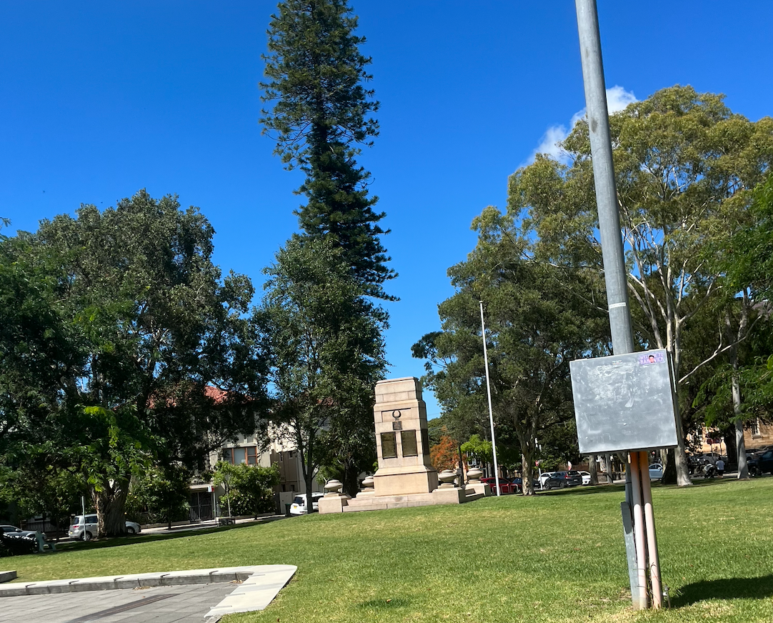

*Figure 5: View once you are on Belmore Road*

1. Continue along Belmore Road for 1.3 km (~15-minute walk) until the Belmore Road, Cuthill Street, and Perouse Road intersection.
2. Cross Cuthill/Coogee Bay Road. onto Perouse Road. See Figure 6 for clarification.



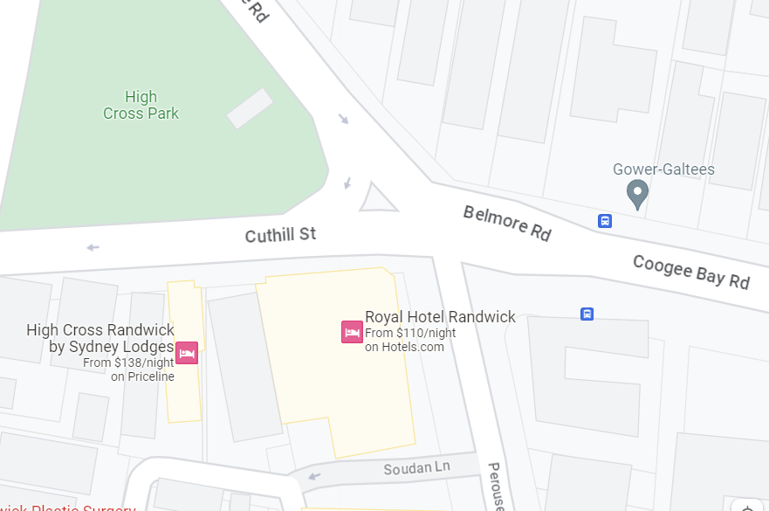

*Figure 6: Google Maps view of the crossing onto Perouse Road.*

**Step 5: From Perouse Road to Bat Country**

1. Continue on Perouse Road. for 240 m   
   *This will take approximately 2 minutes.*
   1. You will cross Soudan Street/Aeolia Street and should see a roundabout ahead of you. Figure 7 depicts the round about.

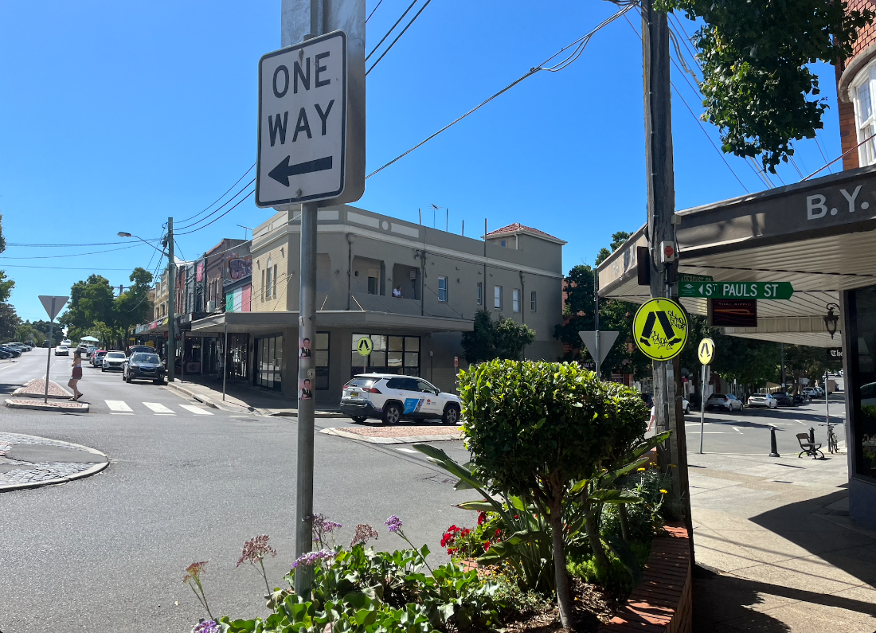

*Figure 7: View round about including St. Pauls Street*

1. At the round-a-bout, cross St. Pauls Street.
   1. Walk across St. Pauls Street using the crosswalk.
   2. Then walk across Perouse Road using the crosswalk.
   3. Continue straight down St. Pauls Street.
2. After a very short 50 m, you will see Bat Country on your right. The storefront is shown in Figure 8.

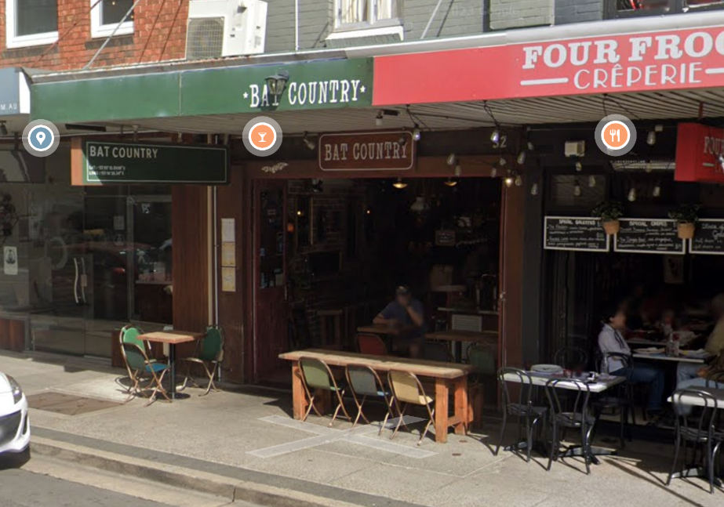

*Figure 8: View of Bat Country storefront from St. Pauls Street*

**Conclusion**

Good on ya for arriving at Bat Country!

By following the above instructions, you will arrive at Bat Country after about half an hour of walking. You walked approximately 2.2km from UNSW village to Bat Country. Please enjoy the wonderful food and drink options this bar has to offer as a tribute to all your hard work. Our group recommends a glass of prosecco to celebrate!

**Work Cited**

“Cocktail Bar: Bat Country: Randwick.” [www.batcountry.com.au/](http://www.batcountry.com.au/). Accessed 9 Nov. 2023.

“Fig Tree Hall.” *UNSW Accommodation*, 14 Sept. 2023, <accommodation.unsw.edu.au/colleges/fig-tree-hall>. Accessed 9 Nov 2023.

“Google Maps.” *Google* [www.google.com/maps/place/Bat+Country/@-33.9203677,151.2405362,17z/data=!3m1!4b1!4m6!3m5!1s0x6b12b222e51c97d5:0x4738c33c37d20d2b!8m2!3d-33.9203722!4d151.2431111!16s%2Fg%2F1ptxzqd1g?entry=ttu.](http://www.google.com/maps/place/Bat+Country/@-33.9203677,151.2405362,17z/data=!3m1!4b1!4m6!3m5!1s0x6b12b222e51c97d5:0x4738c33c37d20d2b!8m2!3d-33.9203722!4d151.2431111!16s%2Fg%2F1ptxzqd1g?entry=ttu.) Accessed 9 Nov. 2023.